 | Monday | Tuesday | Wednesday | Thursday | Friday
Week 1  06th-10th Sept  27th Sept-1st Oct  18th-22nd Oct  15th-19th Nov  6th-10th Dec | Pizza Slices  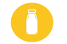  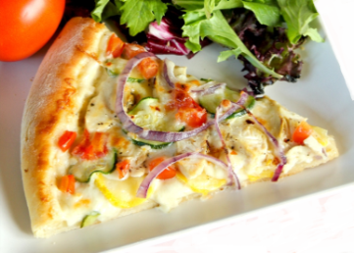 | Fish finger wraps  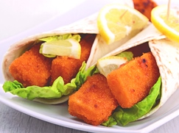 | Baked beans and cheese on bagel or muffin  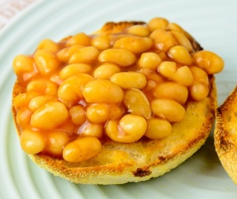 | Macaroni cheese  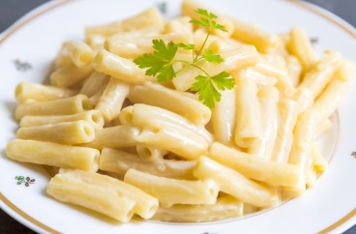 | Chiken bites with potatoe croquettes and carrots  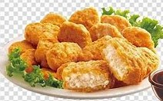
Week 2  13th-17th Sept  4th-8th Oct  1st -5th Nov  22nd-26th Nov  13th-17th Dec | Pasta:creamy tomato sauce  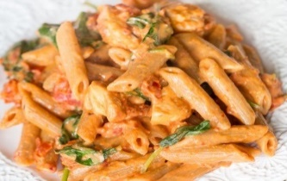 | Baked beans and cheese on potato waffles  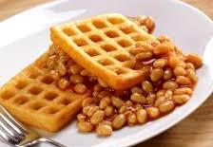 | Pizza slices | 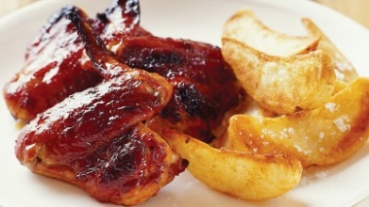  BBQ chiken wings and potato wedges | Wraps: tuna, chicken mayo, cheese, salad  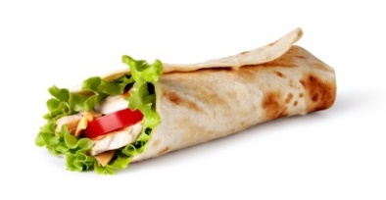
Week 3  20th-24th Sept  11th-15th Oct  8th-12th Nov  29th Nov-3rd Dec | Herby chicken drumstick with coleslaw and salad  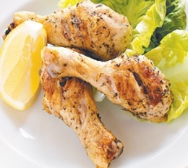 | Wraps: tuna, chicken mayo, cheese, salad  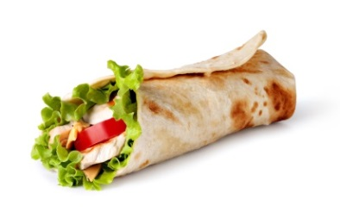 | Fish and chips with peas  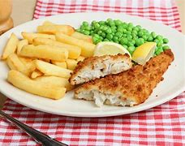 | Pizza Slices | Pasta: Tomato sauce  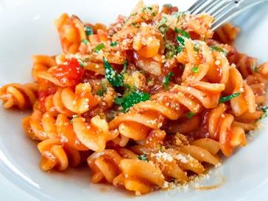
Water, milk and fruit are served every afternoon. A salad bar is available with each meal.

